



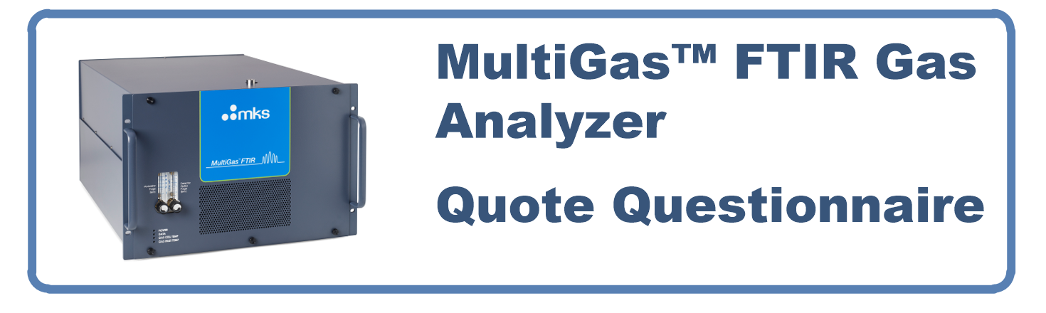

**Please fill in this form as completely as possible to help us determine the optimal system configuration to support your application and return to your Sales Representative or DST-Optical-Gas-Analysis@mksinst.com**

|  |  |  |
| --- | --- | --- |
| **Customer Name** | Required Information | |
| **Company Name** | Required Information | |
| **Address 1** | Required Information | |
| **Address 2** |  | |
| **City/State/Zip** | Required Information | |
| **Phone / FAX** | Required Information | |
| **Email** | Required Information | |
| **Date of this request:** | | **MKS Contact:** |
| **IF DIFFERENT FROM ABOVE:** | | |
| **End User:** | | **Installation Country:** |

|  |
| --- |
| **1. Please describe your application or process?** |
| Required Information |

|  |
| --- |
| **2. What methods or instruments are currently used and why are they insufficient?** |
|  |

|  |  |  |  |  |
| --- | --- | --- | --- | --- |
| **3. Sample Conditions – Please provide the following information** | | | | |
| **Requested Information** | **Range** | | | **Additional Notes** |
| **Sample Gas temperature**  **191oC**  **150oC**  **60oC**   **35oC** | **Minimum**  Required Information | **Nominal** | **Maximum**  Required Information |  |
| **Sample Gas flow rate (in LPM)** | **Minimum**  Required Information | **Nominal** | **Maximum**  Required Information | **NOTE: The MultiGas does not include an integrated pump or sample filtration.** |
| **Desired plumbing interface (size & type of fittings)** | **1/4“ Swagelok male**  **3/8” Swagelok male**  **Swagelok 4 VCR** | | | |

|  |  |  |  |  |  |  |
| --- | --- | --- | --- | --- | --- | --- |
| **4. Please list ALL gas component names, measurement ranges, accuracy requirements your application.** Indicate if the compound is to be measured (YES in Measured column) or is simply present in the sample but does not need to be measured (indicate NO in Measured column). List ALL the gases that will be present at high concentrations (as they can be possible interferents) even if you do not need to measure them (e.g., all gases at % level, H2O, CO2, Air, Matrix Gas if other than N2, eg Argon, Helium, etc…) | | | | | | |
| **Component Name** | **Component Concentration** | | | **Required Detection Limits (ie lowest level to be detected)** | **Accuracy / Repeatability** | **Measured**  **(Yes / No)** |
| **Min** | **Normal** | **Max** |
| **H2O** |  |  |  |  |  |  |
| **CO2** |  |  |  |  |  |  |
|  |  |  |  |  |  |  |
|  |  |  |  |  |  |  |
|  |  |  |  |  |  |  |
|  |  |  |  |  |  |  |
|  |  |  |  |  |  |  |
|  |  |  |  |  |  |  |
|  |  |  |  |  |  |  |
|  |  |  |  |  |  |  |
|  |  |  |  |  |  |  |
|  |  |  |  |  |  |  |

**Important: Make sure to indicate the concentration units (%, ppm, ppb).**

|  |
| --- |
| **5. Do you have any previous experience with FTIR?** |
| **Yes**  **No**  **If yes, which manufacturer of FTIR?** |

|  |
| --- |
| **6. FTIR Detector Options:**  MKS offers both Liquid N2 (LN2) and thermal electrically (TE) cooled MCT detectors. MKS will suggest the appropriate detector depending on your application, gas list and required detection limits. LN2 Detectors offer the most sensitivity and widest wavenumber range but need to be refilled daily or every few days, while TE detectors can run 24/7 without need for LN2 but have a narrower wavenumber range. |
| **Can LN2 be used to cool the detector?**  **Yes**  **No**  (**Required Information)** |
|  |

|  |  |  |  |  |
| --- | --- | --- | --- | --- |
| **7. Installation related questions:** | | | | |
| **Requested Information** | **Range or MKS Available Options** | | | **Additional Notes** |
| **Ambient temperature** **oF or**  **oC** | **Minimum**  Required Information | **Nominal**  Required Information | **Maximum**  Required Information |  |
| **Where will the analyzer be housed?** |  | | | |
| **Will the analyzer be installed in a Climate Controlled area?**  **YES**   **NO** | NOTE: MultiGas Ambient Operating Temperatures:  Optimal operating range 20– 30°C – Range for maximum performance  Extreme operating range 10– 32°C – Loss of signal to noise possible  Optimal Variation - ±3°C (5°F) – no loss of performance, minimum baseline drift | | | |
| **Analyzer voltage requirement** | **120V / 60Hz**  **220V / 50Hz**  **220V / 60Hz**  **Other?** ___________ | | | |

|  |  |  |
| --- | --- | --- |
| **8. Data acquisition and interface measurements** | | |
| **Requested Information** | **MKS Available Options** | **Additional Notes** |
| **Desired measurement rate?** | **5 Hz (200 msec)**  **1 HZ (1sec)**  **5 sec**  **30 sec**  **60 sec**  **Other?** ___________________ |  |
| **Desired data OUTPUT interface and protocol** | **Analog/Digital I/Os**  **OPC**   **MODBUS** |  |
| **Desired data INPUT/OUTPUT interface and protocol** | **AK Protocol**  **Analog/Digital I/Os**  **OPC**  **Toolweb (Included)**  **MODBUS** |  |

|  |
| --- |
| **9. Any special analytical or acceptance criteria needed (e.g. specific EPA, ASTM or DIN regulations).** |
| **EPA 1065/1066**  **Euro 5, 6**  **TUV**  **MCERTS**  **Other?** ___________________ |

|  |
| --- |
| **10. Are there other requirements not covered in any section above?** |
|  |

**Note: MultiGas Analyzers are not equipped with integrated pumps or filters. If an integrated system is required, MKS can suggest one of our trusted integrators to provide sampling system options.**



**For additional information regarding MultiGas specifications or applications please visit:**

[**https://www.mks.com/f/multigas-2030g-ftir-gas-analyzer**](https://www.mks.com/f/multigas-2030g-ftir-gas-analyzer)

**For Sales Representative information, please visit:**

[**https://www.mks.com/contact/contactslocations**](https://www.mks.com/contact/contactslocations)