1150 / 1152 / 1640 Design Request Sheet
Blue shaded cells must be filed out
Step 1 - Application Information – Fill out necessary information
Source material |  | Source temperature °C
Maximum flow rate |  | Maximum process pressure

Step 2- Material Properties – For new materials only
Molecular mass, g/mol |  | Source material decomposition temperature, °C
Source material compatible with
Vapor pressure and gas viscosity information, if available:
Temperature, °C | Vapor pressure, torr |  | Gas viscosity, µpoise

Step 3 - Plumbing Details – It is important to be as complete as possible
Plumbing type | Upstream of MFC | Downstream of MFC
Tubing length
Tubing diameter
Elbows (size & quantity)
Valves (size & quantity)
Recommended tubing diameter:
1150 and 1152: 1/2" (12 mm) OD minimum recommended
1640: 1/4" (6 mm) OD minimum recommended
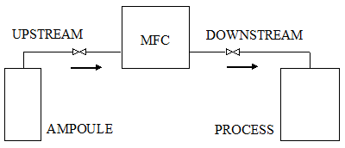

Step 4- Please send completed request to:
Mark_Townsend@mksinst.com and/or Bill_Corkum@mksinst.com
Step 5 - To Be Filled Out by MKS Applications Engineering
Model request number |  | MKS product model number

